Scottish association of change ringers
Learning Methods
Jonathan Frye

Basics

Describing Methods
There are 4 fundamentally different ways of describing and representing a method. Each of them has advantages and disadvantages and differing approaches tend to be used as a ringer progresses through their ringing career. Most ringers, consciously or not, will be using more than one technique at any one time.

Circle of Work
A Circle of Work describes a series of features (usually dodges or places) which are implicitly separated by plain hunt. In visual form this is usually presented as a circle where the starting point is defined by the bell being rung. This is the circle of work for Plain Bob Doubles.

This is usually the technique a ringer will use to learn their first few methods. It lends its self best to methods where the treble plain hunts and the other bells mostly plain hunt. Grandsire is usually learnt in the same way and to some extent it could also be used for Stedman.

Rules
Rules can be used to describe a method and when combined can be used to “work out” the method as you go. Simpler methods can often be described completely by a very small set of straightforward rules. These are the rules for Kent.
- Plain Lead on the front
- Treble Bob in 3-4 and above unless the treble is below you
- Make places in 3-4 when the treble is below you
- If you meet the treble on the front dodge with it and make places at lead and in 2^{nds} alternately until the treble comes back
- The Treble does Treble Bob
Rules have the advantage of needing to learn relatively little compared to learning the work by rote. It also has the advantages of being able to extend the method to higher numbers, for example the above rules are for Kent on all numbers, not just minor. Learning by rules tends to be used when the method contains a lot of repeated work, such as treble dodging and few changes of direction. Having said that it is possible to describe much more complex methods such as Bristol by a fairly small set of rules, it is just harder to see how and when they apply.

Blue Line
A Blue Line shows all of the changes in a plain course of a method and highlights the path that one of the working bells takes through the change. Traditionally the treble is highlighted in red and the working bell in Blue (hence the name). This is the Blue Line for Cambridge Surprise Minor with the 2nd highlighted as the working bell.
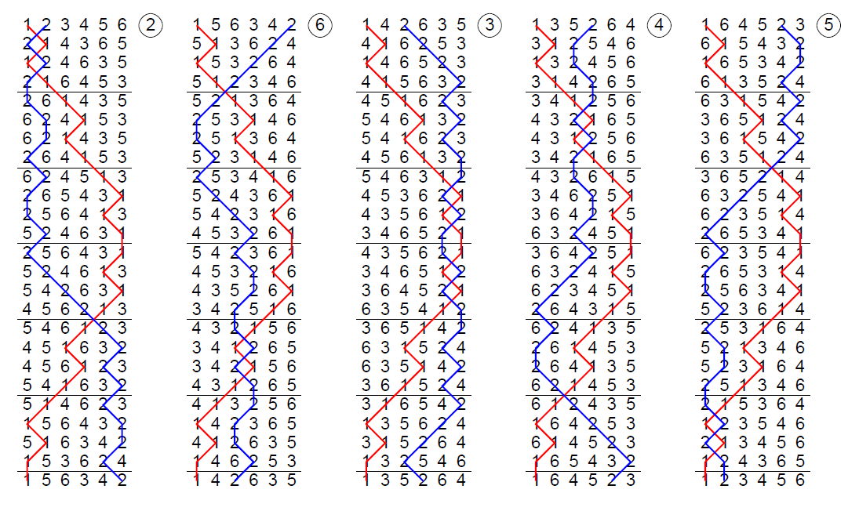
The blue line is probably the most popular way of learning methods. It provides a visual representation of where the bell is in the change and how it interacts with the treble.

Place Notation
The Place Notation for a method describes how each change is different to the last one until the pattern repeats. The place notation describes what all of the bells in the change (including the treble) are doing rather than the work of only one bell. We will go into more detail on how place notation works later. This is the place notation for Norwich Surprise Minor.
x 34 x 14 x 12 x 36 x 34 x 16 – 16
Place notation is the most concise way to learn a method and has the advantage of including information about what all of the other bells are doing around you. This is a difficult technique to master as it requires the ringer to work out what the place notation means for their bell each change. It is particularly appropriate to handbells as only one thing needs to be learnt and kept track of for both bells. Most ringers never use place notation to learn methods but being able to look at a place notation can help with understanding a method’s structure.

Timeline of Techniques
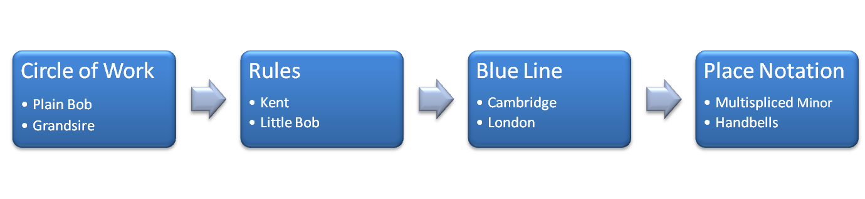

Terminology

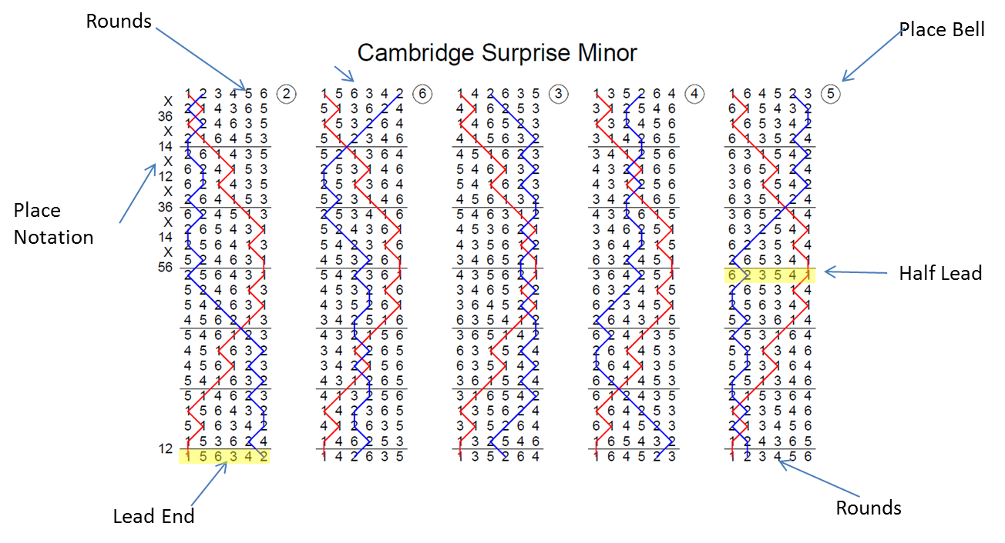

Rounds: The Method starts with rounds and ends with rounds
Lead End: When the treble gets back to lead we refer to the change at the treble’s backstroke as the “lead end”. A Method can be split up into leads, Cambridge Minor has 5.
Half Lead: The half lead is half way through the lead, hence the name. It is the change at the treble’s backstroke while it lies at the back. In almost all methods the lead is symmetrical about this point. Look at 3^{rds} place bell in Cambridge to see this.
Place Notation: This shows how each change differs from the last.
Place Bells: The method is split up into Place Bells, each place bell is one lead long and their numbers correspond to the bell which rings the place bell first in the plain course.

Plain Bob Bob
An often used phrase in the tower is “it’s just a Plain Bob bob” when a ringer asks what the Bobs are in a new method. This is usually met with utter bemusement from a learner who can’t see that the new method looks anything like Plain Bob so how can the bob be the same? The trick is to think about the bob in a different way. The usual way of learning the bob in Plain Bob Minor is:
- If you are about to dodge 3-4 down run in, next time dodge 3-4 down
- If you are about to make 2^{nds} run out, next time make 2^{nds}
- If you are about to dodge 3-4 up make the bob, next time dodge 5-6 down
- If you are at the back you are unaffected.
Instead let’s define the Bob as the following:
At the lead end the treble leads, the bells in 2 and 3 plain hunt, the bell in 4^{ths} place make 4^{ths} and the bells at the back dodge. The bells then pick up the start for the position they are in at the lead end (the treble’s backstroke lead just below the black line).
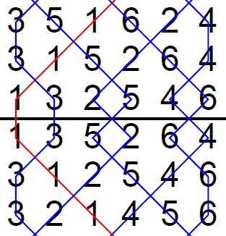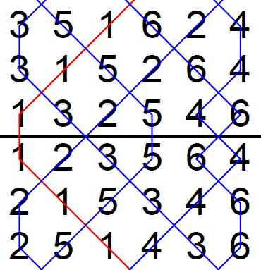
Plain Lead End Bob Called

Now let’s look at Cambridge Minor
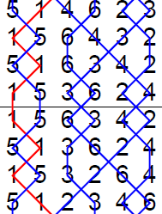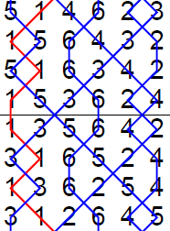
Plain Lead End Bob Called
Look at what happens between the change above the black line and the change below it in Plain Bob and then in Cambridge. Exactly the same! That is why it is called a Plain Bob bob. The same is true of the single. This extends to any number of bells, the back bells just dodge like those in 5-6. Virtually all methods use Plain Bob bobs so once you have grasped the concept you will know how to ring a Bob in almost any method you meet. Notable exceptions which do not have a Plain Bob bob are Grandsire and Stedman.
It is worth noting that in some methods there is plain hunting across the plain lead end rather than dodging, in this case the bob is still the same, i.e. the bells in 2-3 plain hunt, the bell in 4^{tha} makes the Bob and the back bells dodge. This has the effect of leaving the front bells unaffected and affecting the back bells instead. It is still a Plain Bob bob though as the work that happens over the lead is exactly the same.

Place Notation and Method Structure

Place Notation
Place notation is a very succinct way of representing a method. It describes how each change differs from the last one. There are three different symbols which can appear in a place notation, “X” means all bells cross, i.e. the bells in 1-2 swap, the bells in 3-4 swap and so on. A set of numbers, e.g. “14” means that the bells in 1st and 4^{ths} position make places, all other bells swap over in pairs. Finally the “.” Sign separates two consecutive sets of places e.g. 14.56 means that 1st and 4^{ths} are made in one change and then 5^{ths} and 6^{ths} are made the following change. Without the “.” It would be ambiguous whether all of the places should be made in a single change. Written out below are some place notations.

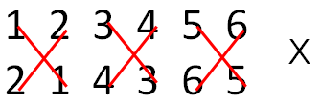

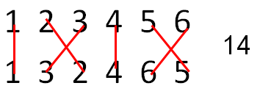
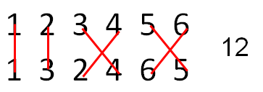
Several of the methods in the handout have the place notation written down the left hand side of the first half lead and at the first lead end. Usually only the place notation for the first half of a method is given as the second half is the reverse of the first half.

Structure
The structure of a method describes how the bells move in the change with respect to the other bells and the lead end. Knowing the structure can be very helpful when slightly lost in a method, “Do I dodge here or not?”. Some methods follow a very simple structure which provides a stand alone way to learn the method without having to learn the blue line, this is very similar to ringing by rules. When learning a method it can be helpful to look at the “grid”. This is a single lead of the method written out but with the line for all of the bells highlighted instead of just one. This shows how the bells interact with each other much more clearly than a blue line does.

Double Norwich is a method with a relatively complex blue line but it actually follows a very simple structure.
- When the treble moves between the even positions (1-2, 3-4, etc) all the bells cross.
- When the treble moves between the odd positions (2-3, 4-5, etc) the bells around it make places, the other bells cross.
- At the half lead and at the lead end all of the bells plain hunt.

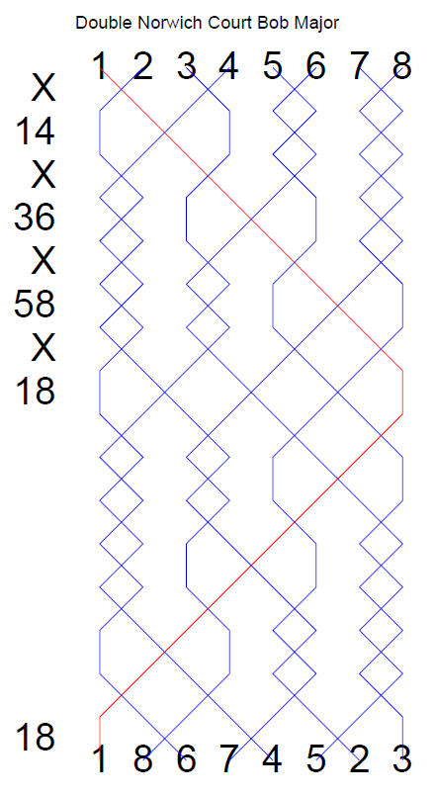

Learning Methods by Over and Under

Rationale
Once a ringer has mastered a few popular methods, usually surprise minor methods, they have the option of learning new methods very very quickly by ringing them as above and below works. Indeed they can be rung in the tower with next to no notice and then promptly forgotten. In some cases it is harder to learn the names than it is to learn the methods!

Splitting Up a Method
A Method needs to be split up into smaller chunks. We have already discussed splitting up a method into individual place bells. We can split it up further into work that happens below the treble and work which happens above the treble. If one method is then rung when your bell is below the treble and another when your bell is above the treble then you have a new method. For example York Surprise Minor is London Surprise Minor below the treble and Cambridge Surprise Minor above the treble.

How to ring it
To ring a new method as above and below works requires you to know the place bells and where you pass the treble for each method. Initially you will start off ringing the above method. At some point you will meet the treble and either dodge with it or plain hunt past it. Here the method switches to the below work. You now need to be able to recall where on the line for the below work the treble appears. For example in London if you pass the treble in 2-3 as you hunt down then you are going down to Stedman whole turn (Lead, point 2^{nds}, lead) on the front as part of 5^{ths} place bell.
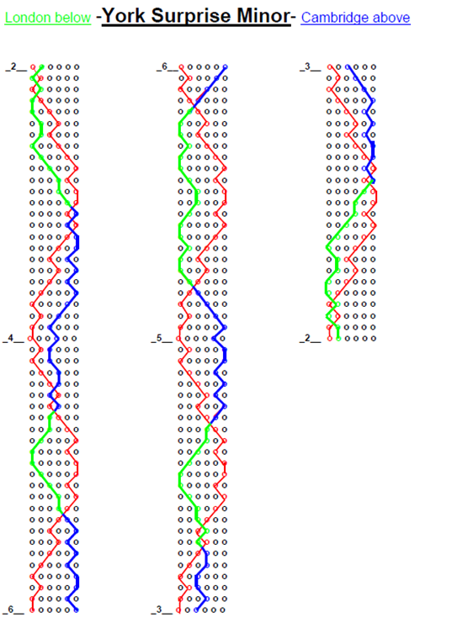

Lead End Variants
Another quick way to learn methods is lead end variants. The new method is the same as the basic method with the sole exception that something different happens over the lead end which results in you becoming a different place bell to the what you would become in the basic method. Very often the variant is to plain hunt through the lead end instead of dodging. This is rather like ringing the basic method with a different type of bob called every lead end. Primrose Surprise Minor is usually the first method of this style attempted. It is Cambridge Minor with plain hunting at the lead end (sometimes referred to as a 16 lead end).
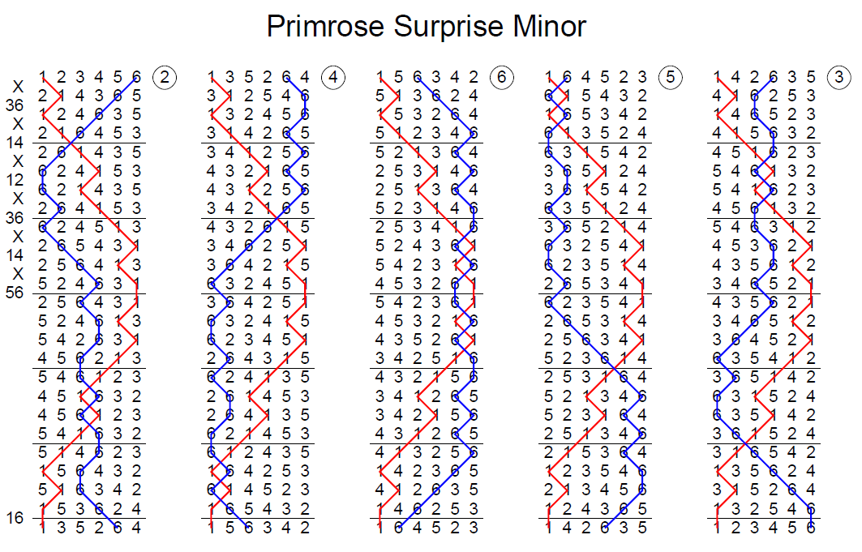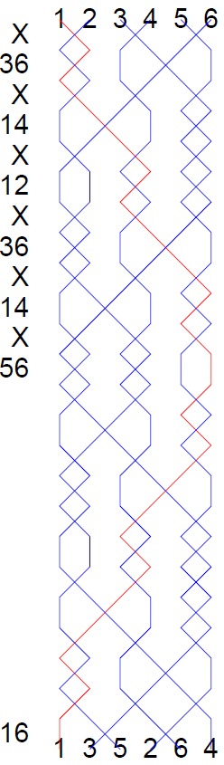

Half Lead Variants
The same thing can be done at the half lead. This requires you to have learnt the half lead place bells (a useful exercise in any case). Ipswich Surprise Minor is Cambridge with Plain Hunting at the half lead (sometimes referred to as a 16 half lead). Finally Norfolk Surprise Minor is Cambridge with 16 Lead End and a 16 Half Lead.

In methods such as Little Bob where the treble does not get to the back the half lead is still halfway through the lead, i.e. when the treble is making 4^{ths}.

